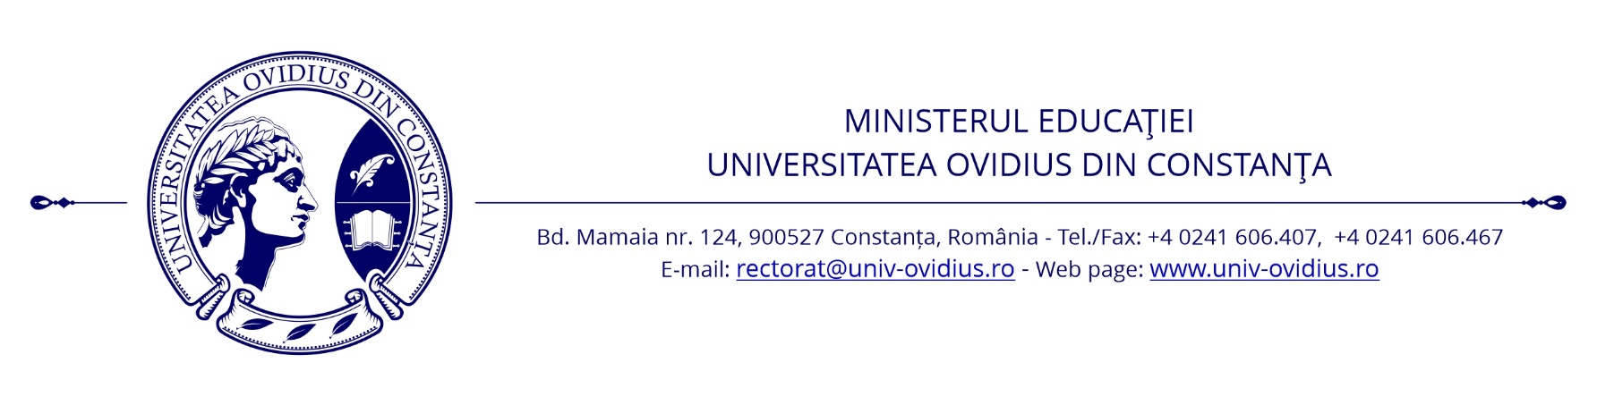
GDPR STATEMENT
According EU Regulation no. 679/2016

I, the undersigned ___________________________________, declare that, in accordance with the requirements of EU Regulation 679/2016, hereinafter referred to as RGPD, I have taken note that OVIDIUS University of Constanta, based in Constanta, University Alley no. 1, Campus, Corp A, postal code 900470, telephone / fax +40 241 606407, +40 241 606467,, email: rectorat@univ-ovidius.ro, legally represented by the Rector - Assoc. Prof. Dr. Dan Marcel Iliescu, as a personal data controller, has the legal obligation to process my personal data, by automated / manual means, in order to organize and conduct entrance exams at the University, according to the provisions of The Law of Higher Education no. 199/ 2023 and incidental secondary legislation.
Personal data: name and surname; parents' first and last name; date and place of birth; domicile / address; citizenship (as appropriate); urban / rural background; personal numerical code (CNP); the series and number of the identity document; signature; the photo (image) from the identity card and the competition card; phone number; email address; the name of the graduated institution / educational unit; series / number of diploma; workplace (as appropriate); position / profession (as appropriate); medical data attesting the ability to have a medical quality as a student; medical data resulting from the epidemiological triage; marital status; ethnic origin (as appropriate); religious denomination (as appropriate); video images and screenshots proving my online examination (if applicable); the image of the identity card presented during the video recordings / screenshots as proof of my identity (as the case may be); are obtained by completing and signing the application for the admission contest held at the OVIDIUS University of Constanta, from the documents attached to it, by completing and signing the agreement form in Annex 1 of the Procedure on online assessment of students from OVIDIUS University of Constanta (if applicable), as well as following my participation in the online examinations and/or the epidemiological triage (if applicable). This information is entered by the University in its database in any material form (on paper) and electronically.
By this declaration I give my consent for the processing of personal data on ethnic origin in case I apply for admission to one of the study places reserved for romanians from everywhere, personal data on membership in a particular religious denomination if I apply for admission to studies carried out within the Faculty of Theology of the University, as well as the personal medical data included in the medical certificates or obtained following the epidemiological triage.
The purpose of data collection is to implement the act/procedure of registration and participation (including online with video recording of the examination, as appropriate) in the entrance exam at OVIDIUS University of Constanta, according to my request, to initiate and execute reports legal obligations between the undersigned and the university, as well as in order to fulfill its legal obligations to OVIDIUS University of Constanta to administer, process and transmit in safe conditions, including through the RMU and other public registers provided by law and only for the purposes provided by applicable law, my personal data.
The legal basis for the collection and processing of my personal data for the purpose mentioned above is: my consent, application for admission contest at OVIDIUS University of Constanta, the agreement form in Annex 1 of the Online Assessment Procedure of students from the OVIDIUS University of Constanta (if applicable), The Law of Higher Education no. 199/ 2023, Law no. 16/1996 of the National Archives, republished, with subsequent amendments and completions.
At the same time, I have taken note that my personal data are transmitted, by any means of communication, to the following recipients: the data subject (the undersigned), by publicly displaying the results of exams and information on their organization and by participating in the online examination activities carried out through the software platforms accepted by the Procedure on the online assesment of students at OVIDIUS University of Constanta (Webex Meetings/Teams, Zoom, Microsoft Teams, Moodle, etc., if applicable), other candidates participating in the same online examination activities when identifying participants (if applicable), teachers performing the evaluation, structures within the University, as well as public institutions / authorities (eg. Ministry of Education, DSP), tax authorities, verification and control authorities, under the conditions established by law, have other public or private entities whose activities are incidental in the activity of OVIDIUS University of Constanta, or which are directly or implicitly related to the instrumentation of the act or procedures for which we initiated legal relations with the University and which, in turn, are operators of personal data.
According to EU Regulation no. 679/2016, I have been informed that I have the following rights: the right to be informed about the processing of my personal data; the right to restrict the processing of personal data and the right to oppose such processing, as long as these things do not contravene the legal obligations of the University; the right to data portability; the right of free access to personal data; the right to rectify or delete personal data ("the right to be forgotten"), as long as this does not contravene the legal obligations of the University; the right to withdraw consent at any time, in the specific case where the collection and processing of data is based on consent and there is no contractual or legal provision providing for the obligation to collect and process data; the right not to be subject to an automated individualized decision, including the creation of individual profiles; the right to lodge a complaint with the supervisory authority of the processing of personal data or to go to court regarding the processing of my personal data. I have taken note of the fact that for the exercise of the respective rights I can address either the University headquarters or the email address dpo@univ-ovidius.ro.
I have also been informed that my personal data will be processed/stored at OVIDIUS University of Constanta in accordance with the legal provisions under which deadlines for processing such data are regulated, such as, for example, the legal provisions governing the archiving of documents or the legal provisions governing the activity and functioning of higher education institutions. I also noted that, in particular, the video recordings and screenshots of the online examination activities, which are evidence of those examination activities, will be archived and kept by the University throughout the academic year following the admittance.
I acknowledge that I am obliged to provide the data necessary to achieve the above purpose and that the refusal to provide or provide such data incorrectly and/or incompletely makes it impossible for the university to initiate or, if applicable, complete the act or procedure, as it would result in non-compliance with specific legal regulations in the field of education.

Date: Name and Surname:

Signature:

